
AGRICULTURAL UNIVERSITY OF ATHENS
SCHOOL OF ENVIRONMENT AND AGRICULTURAL ENGINEERING
Department of Natural Resources Development and Agricultural Engineering
MSc: Greenhouses – New Technologies and Sustainable Cultivation Practices

A14 Regulation of Operation of the Institution of Academic Advisor for Postgraduate Studies

Iera Odos 75, 118 55 Athens
Rousopoulos Building

- Legal framework

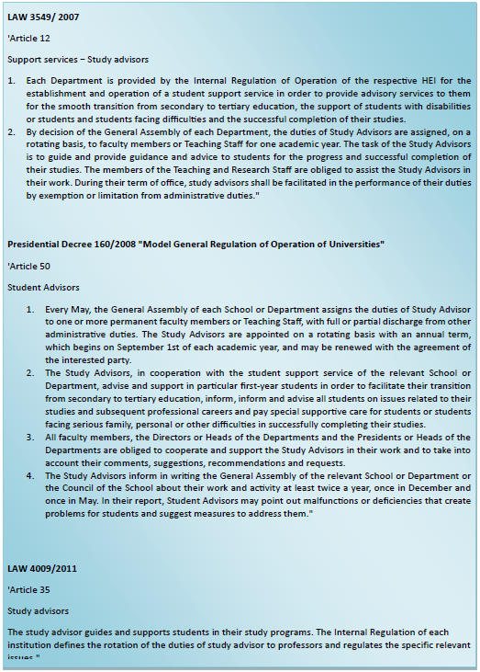

- Definition of the Academic Advisor

The Academic Advisor is a member of the Teaching and Research Staff of the Department, whose main task is to support and guide students, first and second cycle, who address him, in order to effectively organize and successfully complete their studies.

In particular, the Academic Advisor:
- supports and facilitates first-year students in their transition from secondary to tertiary education
- discusses and informs about the structure of the curriculum and the content of the courses offered, the compulsory and elective courses of the specialization, as well as the prerequisite knowledge for attending specific courses
- provides guidance for the effective organization of the student's educational obligations,
- discusses the results of the examinations and the course of his/her studies and jointly seeks solutions to the problems that the student may face.
- informs about the intended learning outcomes of the curriculum and the professional prospects of graduates
- The choice of thesis topic or other work Professional prospects (opportunities in the public, private sector, freelance profession, job abroad).
- Any family, personal or other matter that affects studies.
- informs about prospects and possibilities for postgraduate and doctoral studies and helps him make choices
- informs about the services offered by AUA to students, such as Student Welfare, Liaison Office, Library and Information Center, Internship Office, Office of Innovation and Technology Transfer

- How are Academic Advisors (ASPs) appointed?

- Academic Advisors can be appointed all members of the Teaching and Research Staff of each Department. Exceptions are faculty members who are justifiably absent for a long time (due to educational leave, health problem, etc.)
- The Academic Advisors are appointed by decision of the Assembly of the Department at the beginning of the academic year.

- Faculty members are assigned the support of a group of first-year undergraduate and postgraduate students and maintain their role – as far as they are concerned – throughout their formal course of study.
- An exception to the above rule is:
- In the case of Undergraduate Programs of Studies where there are directions: after the choice of direction by the student, if the Academic Advisor assigned to him in the 1st year of studies is not a faculty member of the direction chosen by the student, then a new Academic Advisor of Studies may be appointed according to the direction of the student.
- In exceptional cases and if there are serious reasons, the student may request the change of his/her Academic Advisor by submitting a substantiated application to the Secretariat of the Department. The possibility of satisfying the student's request will be examined at the first meeting of the Assembly after the submission of the application. In any case, the change of Academic Advisor requires a majority of 3/4 of the members of the Assembly.
- The process is repeated for students enrolled within the academic year, such as cases of transfers and special category admissions.

- The process is repeated for students enrolled within the academic year, such as cases of transfers and special category admissions.

Each student is notified of the Academic Advisor assigned to him. This is done in many ways: via e-mail, personally from the Secretariat of the Department, through the website of the Department, etc.
The Academic Advisors together with the students determine the schedule of their meetings during each academic year in the following way:

- The 1st meeting will take place during the 1st month of each academic year
- The 2nd meeting in the middle of the academic year and
- The 3rd meeting at the end of the academic year

In exceptional cases, extraordinary meetings may be convened if deemed necessary by both parties, or if requested by the ASC in order to discuss a major issue concerning students.

- Support of the institution by the members of the academic community
The Academic Advisor informs the Assembly of his Department about the progress of the institution and conveys to it the problems expressed by students and related to the operation of the Department. It highlights any malfunctions or deficiencies that create problems for students and proposes measures to address them as well as good practices that are already applied to maintain or even strengthen them.
- Objective of the institution of the Academic Advisor
The aim of the institution of the ASS is:
- to support students in completing their studies on time
- highlighting the points that may hinder attendance and taking similar initiatives to reduce or eliminate them
- facilitate communication between students and faculty
- to increase students' interest in participating more effectively in their studies and in the University's events.

The Chair of the Department
of Natural Resources Management and Agricultural Engineering

Professor Ioannis Papanikolaou

